# Gendler Grapevine Interfaith Food Justice

* [Home](https://newroots.org/)
* Gendler Grapevine Interfaith Food Justice

#### **Gendler Grapevine Interfaith Food Justice Initiative**

*The Gendler Grapevine Project was a six-year initiative that promotes activities within the Jewish and interfaith communities honoring and supporting the values affirmed by Rabbi Everett Gendler. The Project facilitates the creation of effective, innovative, and replicable programs that celebrate the deep connections between Jewish traditions, social justice and the environment, helping others transform their words and ideas into activities that will make a difference not only in their own lives but also for those around them.*

New Roots was a 2015, 2016, and 2017 (see below) recipient of the Gendler Grapevine L’dor V’dor Grant which supports environmental and social justice projects at non-profit organizations across the United States. These grants:

* Helped New Roots to create the Parkland Fresh Stop Market in partnership with Congregation Adath Jeshurun. Many Parkland residents struggle with limited resources and the Fresh Stop Market is the only channel for farm-fresh organic food in the neighborhood. This Market was created, is run by, and is sustained by members of the Pleasant View Baptist Church and Congregation AJ along side the residents of the Parkland Neighborhood;
* Invested in the formation of the first Fresh Stop Market at a Jewish Community Center in the entire country.The Gendler Grapevine Fresh Stop Market @ the J is one of the most successful Markets in the region with an average of 70 families every other week; and,
* An interfaith food justice movement where Jews, Muslims and Christians come together to pursue fresh food as a basic human right.

The idea that Jews must pursue—in fact run after—justice, is at the core of this initiative. This theme guides our work at New Roots. We understand that the meaning of the word tzedakahis not about an act of condescension from one person to another who is in need. It is the fulfillment of a mitzvah, a commandment, to a fellow human being who has equal status before God. Although Jewish tradition recognizes that the sharing of our resources is also an act of love—as the Torah states, “Love thy neighbor as thyself” (Lev.19:18), it emphasizes that this act of sharing is an act of justice. We do not believe that people are “under-served,” “needy,” or that we have to “empower” them.

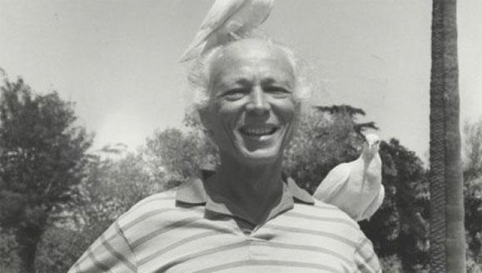

#### **Rabbi Gendler**

Rabbi Gendler’s challenge is to:

“Tune into heaven but keep feet on earth”

This a call to:

“Pray with our feet, and become God’s light in the world as active doers.”

To us at New Roots:

“Doing” means working to obtain food justice for all.

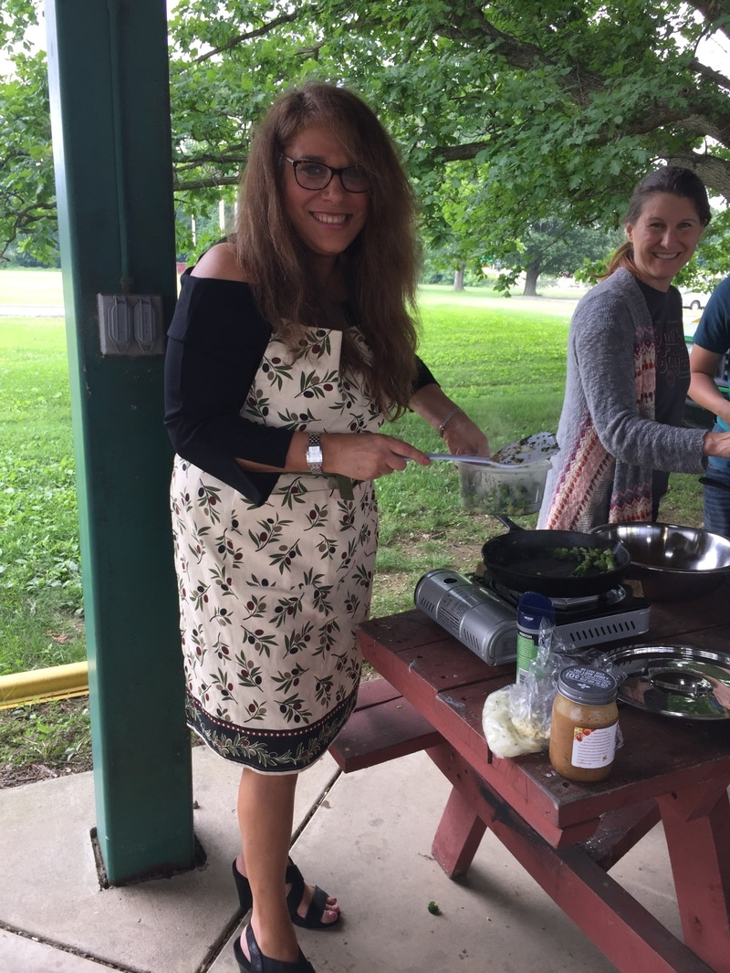

Chef Elana Levitz cooking from scratch with organic, farm-fresh veggies at the Gendler Grapevine Fresh Stop Market @ The J.

#### **The goal of the 2017-2018 Gendler Grapevine Initiative was:**

*Creation of a Youth Food Justice Corps and testing the replication of the New Roots Fresh Stop Market model*

This project united communities to spread food justice in Louisville and beyond and engage youth as true leaders in the movement. Here’s what we did:

New Roots focused on the next generation of food justice organizers. We worked with 12- to 14-year olds who:

* Learned from and shadow adult food justice leaders at the Fresh Stop Markets and Fresh Stop Training Institute;
* Learn how to leverage their technological fluency for the purpose of social change;
* Organize within the Jewish community, their schools, and other spaces they inhabit to grow the local food justice movement;
* Learn the basic Jewish values of Tzedakah and Tikkun Olam; and,
* Work with New Roots professionals.

New Roots is also extending networking with other Jewish Community Centers and Jewish communities that are interested in creating a Fresh Stop Market in their food-insecure neighborhood to replicate New Roots’ model, or just sharing knowledge on food justice work.

We will pursue these goals in partnership with the Gendler Grapevine Foundation, our Louisville-based Hazon Jofee Fellow, Michael Fraade, the Jewish Community of Louisville, and Jewish communities around the region. Please call Karyn Moskowitz @ 502-509-6770 Ext. 703 to learn more.New Roots had a very successful 2018 growing season with our Gendler Grapevine Fresh Stop Market @ The J and is now about to kick off a 2019 summer Fresh Stop Market.

See more about the Gendler Grapevine Project [here.](http://www.gendlergrapevine.org/)